**Lesson 7 Demo 1**

**Setting up New Linux VM as Slave machine**

Steps to be followed:

1. Log in to Jenkins CI tool and create new Slave configurations in Jenkins
2. Configure custom user on slave VM for SSH connectivity from Jenkins’s master

**Step 1: Log in to Jenkins CI tool and create new Slave configurations in Jenkins**

1. First login to Jenkins and Navigate to Manage Jenkins and then Manage Nodes.
2. Then click on New Node and provide Node name.

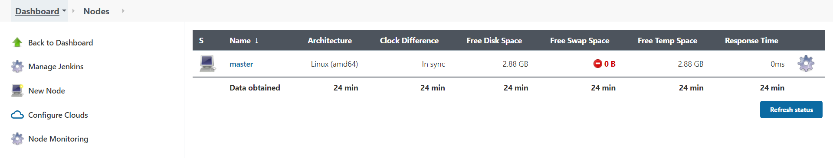

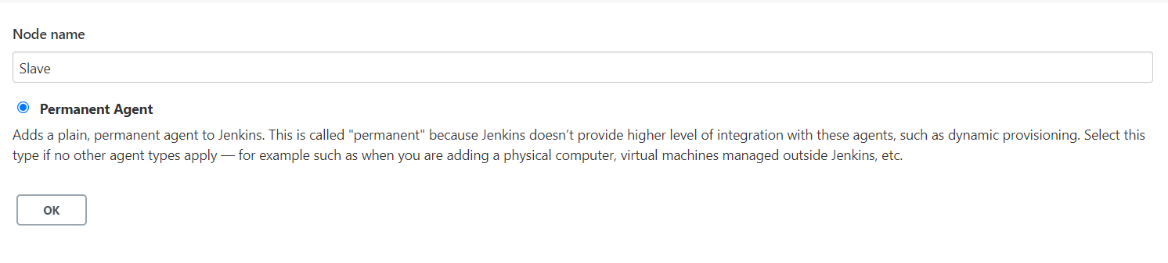

1. Next provide Agent name, Number of executors and remote home directory where jenkins workspace and other required files would be deployed.

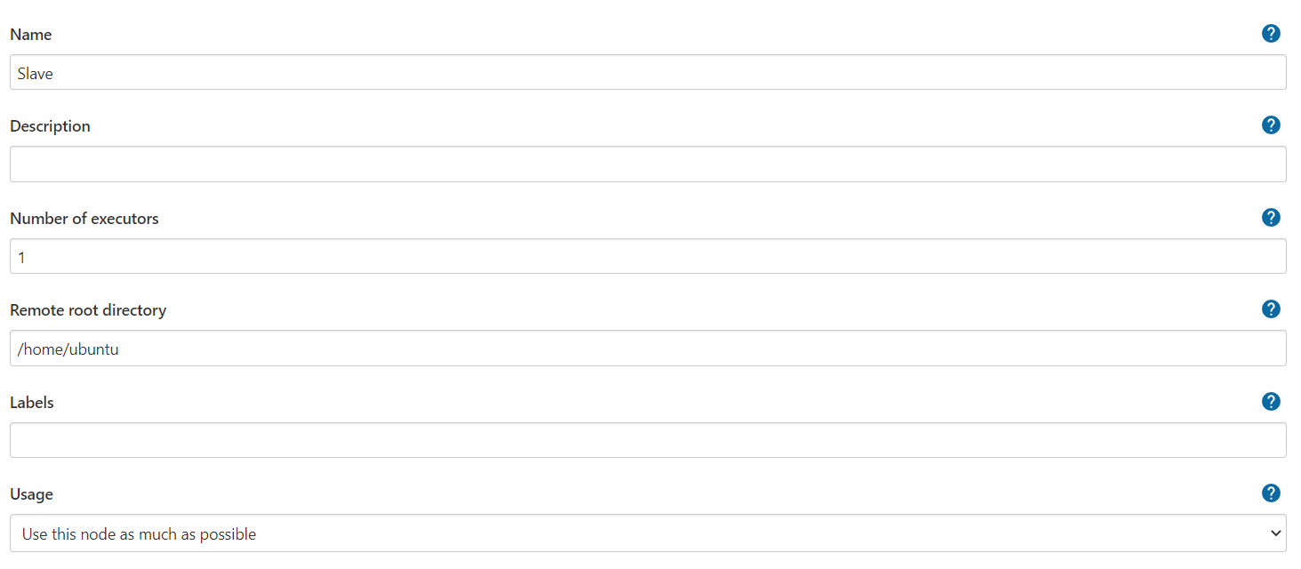

1. Next in order to connect with slave from Jenkins master you need to select Launch method as SSH and then provide hostname or IP, Credentials to login using SSH and then host key disabled so that we don’t have to verify SSH connection using known hosts.

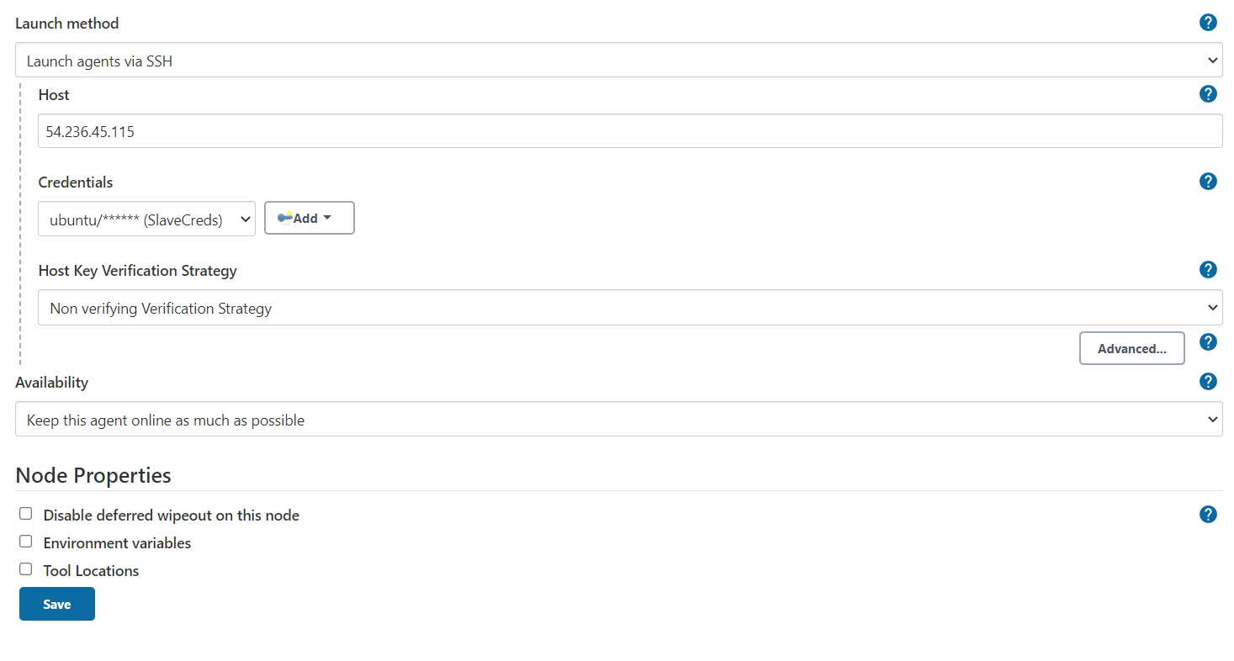

For creating credentials refer to Lesson 4 Demo 2 where we have shown how to create credentials.

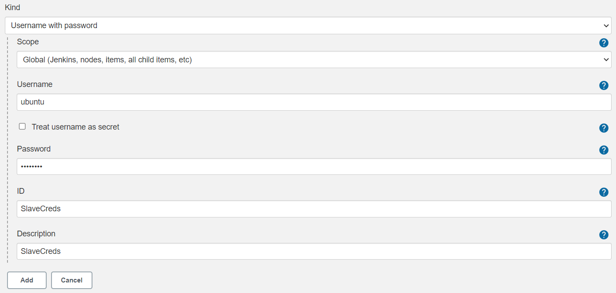

1. Save Slave configuration once all required parameters are provided.

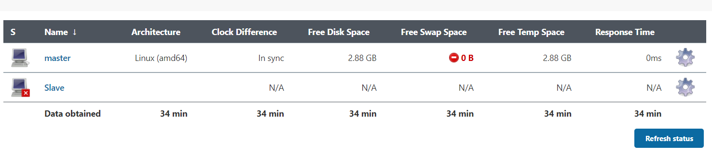

**Step 2: Configure custom user on slave VM for SSH connectivity from Jenkins’s master.**

1. Once configurations are completed, lets configure this user on slave VM using below set of commands. Connect to slave VM using root id to reset password and allow SSH using passwords.

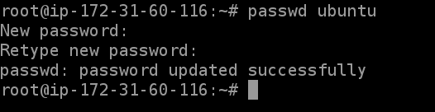

1. Next you need to modify configuration file to allow Password Based SSH and then restart SSH service.

**vi /etc/ssh/sshd_config**

Change parameter **PasswordAuthentication no** to **PasswordAuthentication yes.**

1. In order to run Slave process we need Java installation on Slave machine. Execute below commands to install JDK.

**apt install default-jdk**

1. Once above configurations are completed you can then perform restart of sshd service using **service sshd restart**.
2. Post that you need to relaunch slave in Jenkins to re-establish connectivity with slave agent.

